Name: Astha Arpit Bhatt

Enroll: 196140316006

**Practical 7**

Aim: Develop a program that has only one button in the frame, clicking on the button cycles through the colors: red->green->blue and so on. One color changes per click.

Code:

import java.awt.*;

import java.awt.event.*;

public class pra7 implements ActionListener

{

Frame f;

Button b;

public pra7()

{

f = new Frame("pra7");

b = new Button("Click");

b.setBackground(Color.RED);

f.setBackground(Color.RED);

b.addActionListener(this);

f.setLayout(new FlowLayout());

f.add(b);

f.setSize(300,300);

f.setVisible(true);

}

public void actionPerformed(ActionEvent o)

{

if(f.getBackground() == Color.BLUE)

{

b.setBackground(Color.RED);

f.setBackground(Color.RED);

}

else if(f.getBackground() == Color.RED)

{

b.setBackground(Color.GREEN);

f.setBackground(Color.GREEN);

}

else if(f.getBackground() == Color.GREEN)

{

b.setBackground(Color.BLUE);

f.setBackground(Color.BLUE);

}

}

public static void main(String args[])

{

pra7 o = new pra7();

}

}

Output:

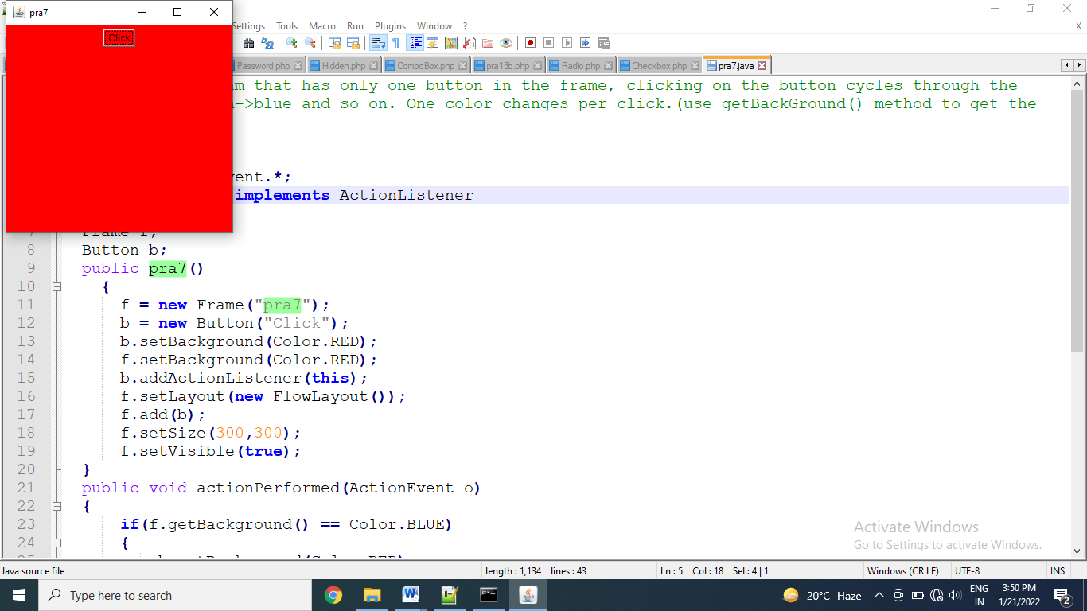

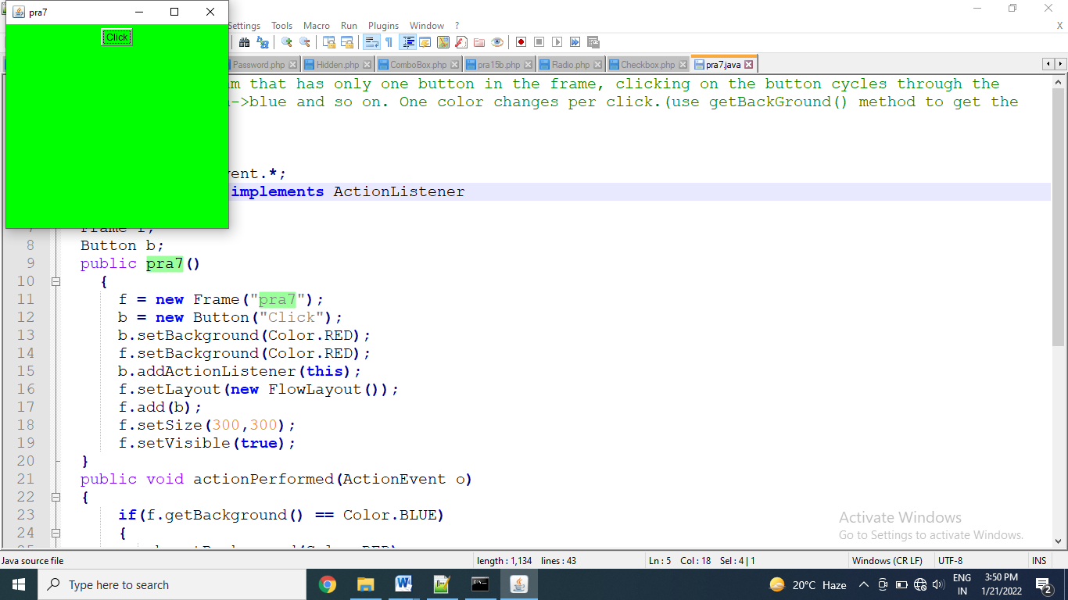

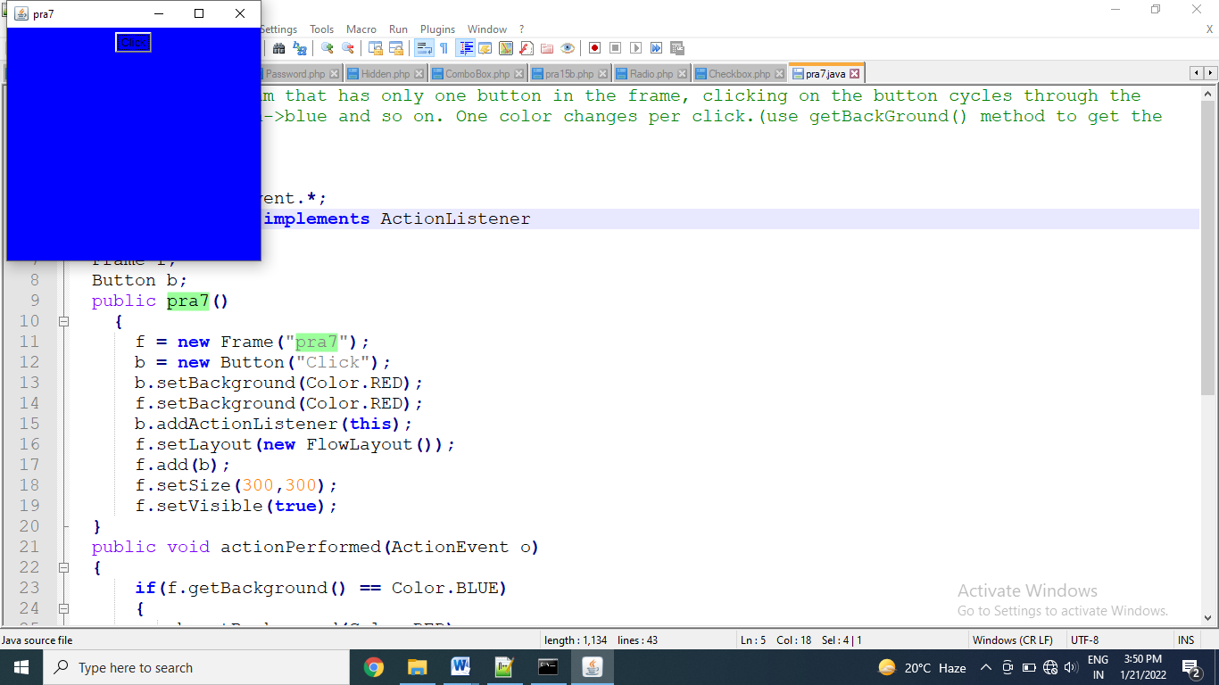

Thanks mam!!